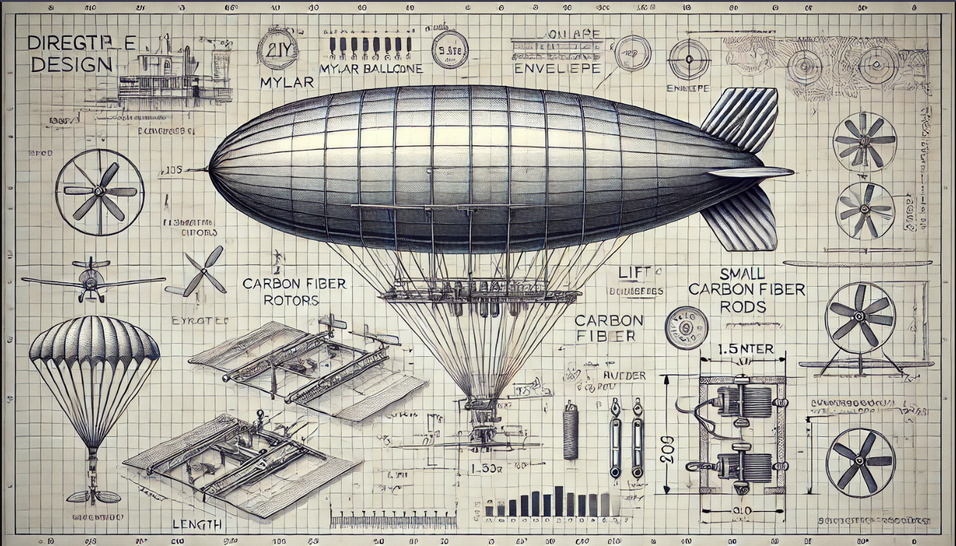

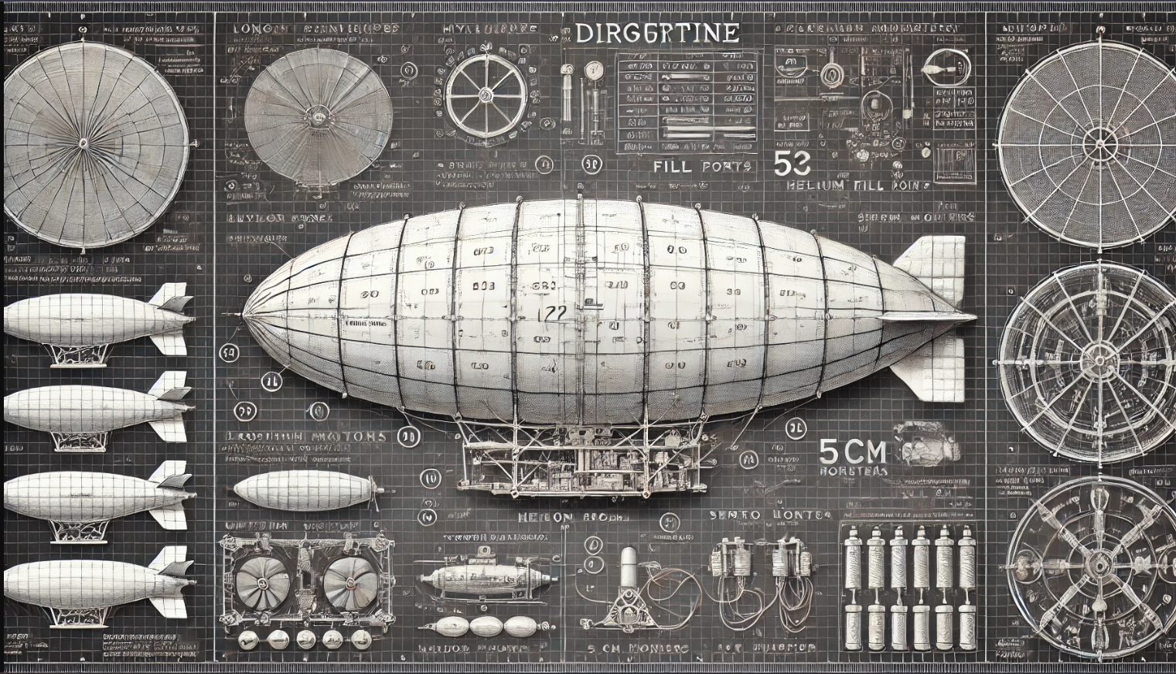

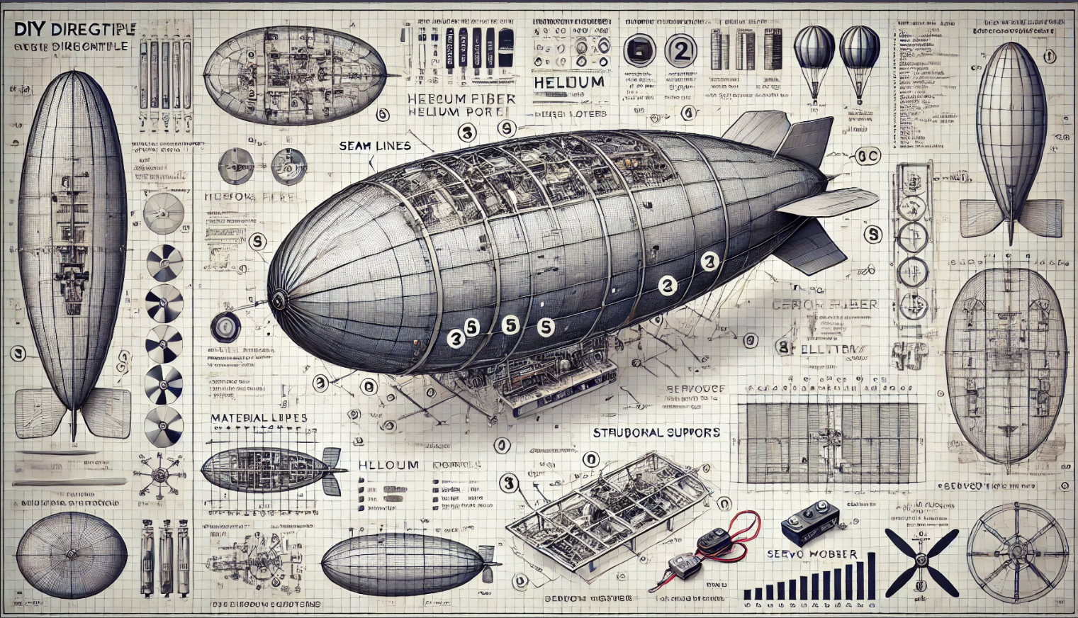

**Materials Needed:**

#### **Envelope (Mylar Balloon or Custom Material)**

* **Material**: 2 square meters of Mylar sheet, 5-micron thickness (lightweight and airtight).
* **Helium port**: A small valve suitable for helium inflation.
* **Sealant**: Heat sealer or airtight double-sided adhesive tape.

#### **Frame (Carbon Fiber or Similar Lightweight Material)**

* **Carbon fiber rods**:
  + 2 pieces, 1 meter each (for the long sides).
  + 2 pieces, 0.3 meters each (for the shorter sides).
  + 2 pieces, 0.1 meters each (for vertical supports).
* **Connectors**: Nylon brackets for securing corners or lightweight epoxy glue.

#### **Propulsion System**

* **Motors**:
  + 2 DC brushless motors (e.g., 1806 motors for drones).
  + Thrust: 200-300 grams each.
* **Propellers**:
  + 2 pieces, 5 cm diameter, compatible with the motors.
* **Electronic Speed Controllers (ESCs)**:
  + 2 small ESCs to regulate motor speed.

#### **Control Surfaces (Rudder and Elevator)**

* **Material**: Thin plastic or foam sheets for lightweight control surfaces.
* **Hinges**:
  + 4 small plastic or metal hinges (2 per surface).
* **Servo motors**:
  + 2 mini servos (e.g., SG90 or similar).

#### **Electrical Components**

* **Battery**: 7.4V 2S LiPo battery, 1000-1500mAh.
* **RC Receiver and Controller**: 4-channel RC transmitter and receiver set.
* **Wiring**: Lightweight insulated copper wires (20-22 gauge).
* **Miscellaneous**: JST connectors, soldering wire, and a small soldering iron.

#### **Miscellaneous Tools**

* Heat sealer or tape, small screwdriver set, wire cutters, zip ties, and lightweight glue.

Assembly:

#### **Step 1: Attach Motors and Propellers**

1. **Bracket Mounting**:
   * Use nylon brackets or clamps to attach the motors to the sides of the carbon fiber frame. Ensure they are secured symmetrically to maintain balance.
   * Use screws to fix the motors onto the brackets tightly.
2. **Attach Propellers**:
   * Place the propellers onto the motor shafts, aligning them with the motor threads.
   * Tighten the propeller nuts to ensure they are securely attached.
3. **Wire the Motors**:
   * Connect the motor leads to the ESCs. Use soldering or connectors to ensure solid connections.
   * Route the ESC wires neatly along the frame using zip ties.

#### **Step 2: Install Control Surfaces**

1. **Cut and Shape the Surfaces**:
   * Cut the rudder and elevator out of foam or thin plastic sheets. Dimensions: rudder (8x5 cm), elevator (10x4 cm).
2. **Hinge Installation**:
   * Attach 2 small hinges to each control surface using glue or screws.
   * Secure the hinges onto the rear of the frame.
3. **Attach Servo Motors**:
   * Mount the servos near the rudder and elevator.
   * Use servo horns and linkages to connect the servos to the control surfaces.
   * Test the range of motion to ensure smooth operation.

#### **Step 3: Wire the Components**

1. **Connect Motors to Receiver**:
   * Plug the ESC signal wires into the designated channels on the receiver.
2. **Connect Servo Motors to Receiver**:
   * Plug the servo signal wires into channels designated for rudder and elevator control.
3. **Power Setup**:
   * Connect the battery to the ESCs using a JST connector.
4. **Test Connections**:
   * Power on the system and test motor and servo operations using the RC transmitter. Adjust as necessary.